- Change the logo – to what u have shown me
- The name is showing twice,
- 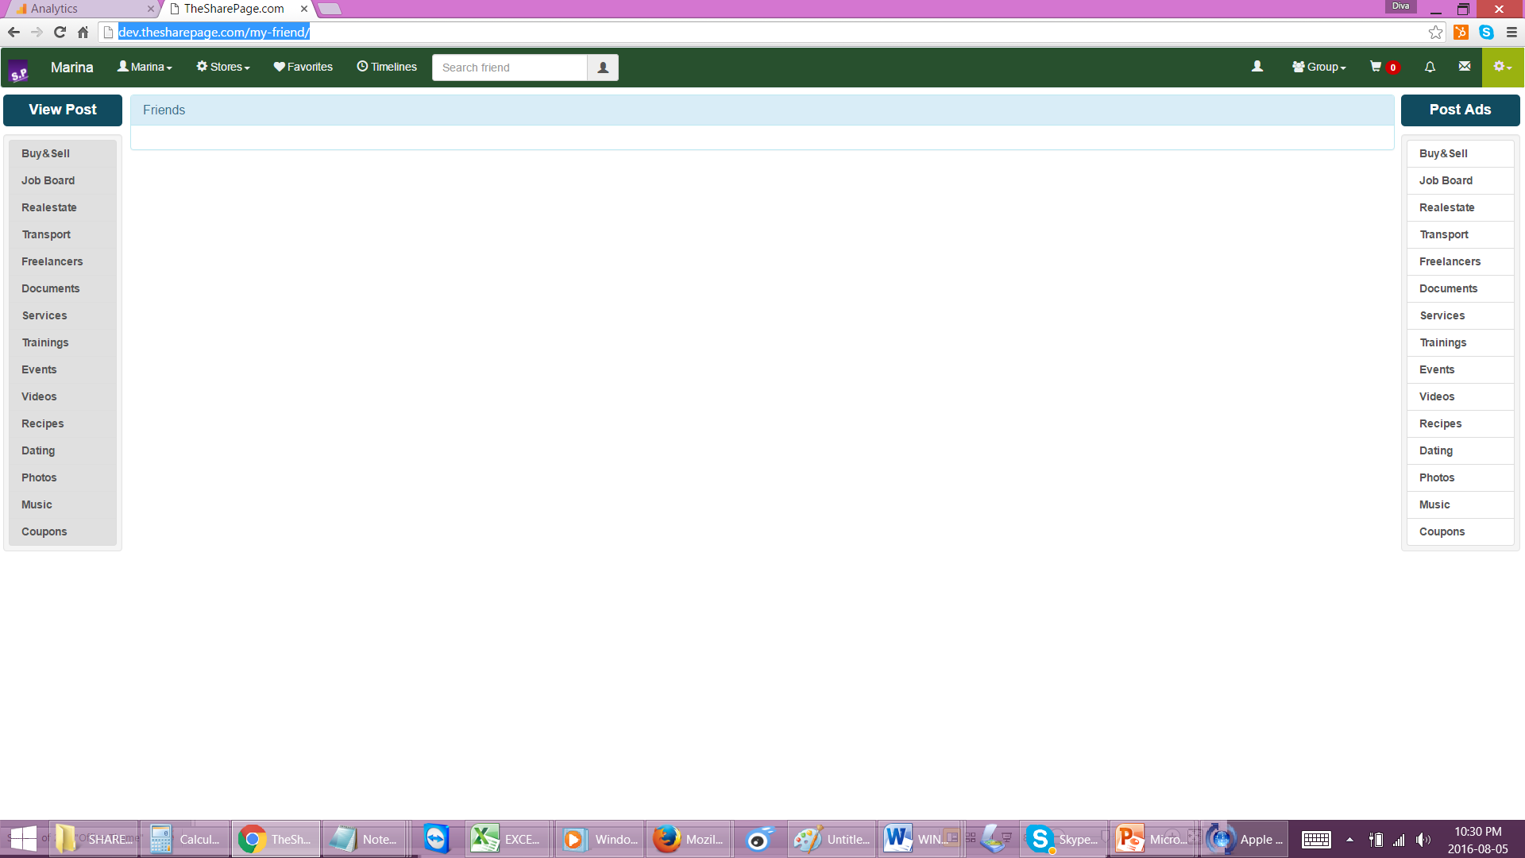
- Change the submenu colour to 7e846b
- Timeline – when I post something I should be able to select a group to post it under and it should go to the group I selected.
- When I am on the groups timeline, I should be able to add friends to the group,from the users page
- There should be a BACK button on every page to return to the previous page, .
- Editing a draft (of buy&sell), is not showing up the image, when I clicked on Edit Draft.
- Images are still distorted! Its not showing its original size
- Also I uploaded 3 images but its not working. Only one image loaded ( from buysell
- REMOVE the percentage Discount, as the first label to show!! It should show the title of the product, not % discount as the first message!

- 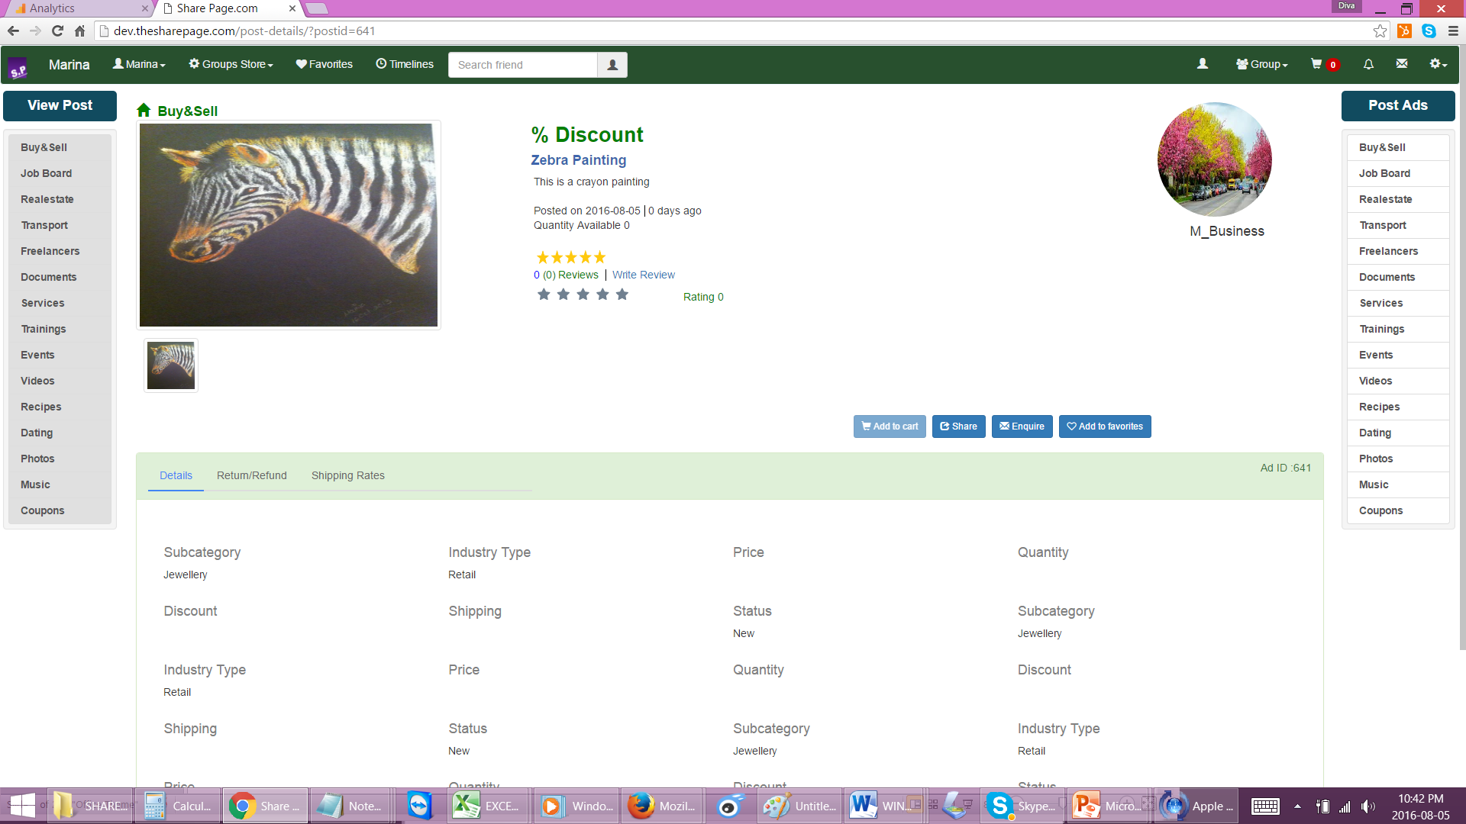
- When I created a business profile, it didn’t give me all the fields, to add information like about sstore, shipping rates etc. Please make sure all these fields show up on the creating the profile also
- I added the shipping rates and returns but they are not saving.
- The return value should be in %, not in $
- It should show up in the profile when I submit rates but it is not staying
- Posted item – when editing - is not working –
  - It loses the image
  - The price, quantity!!
  - Discount
  - More fields – the values just disappear!!
- Preview post is not showing the image and doesn’t show how it should look in the Vie post. It should show EXACTLY how it should look in the view post page that’s why its Preview. But its not working
- 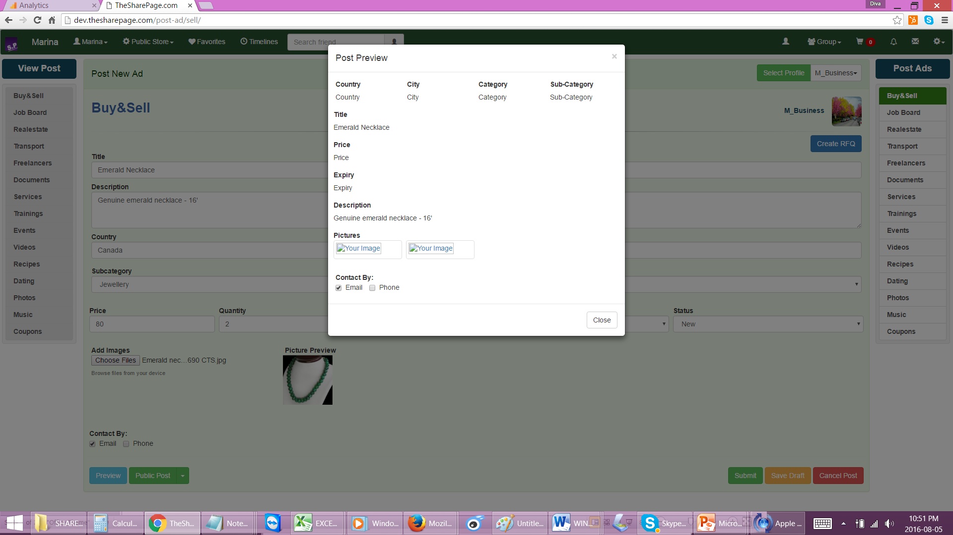
- In the VIEW POSTS – the products that are posted in a group should not show up on the public posting. But it is still showing in the public posting, I shared the post of Zebra painting with one group but It is still showing up in the public posting!
- ALL POSTS – which have multiple images, should have arrow to show next and previous photos
- TIMELINE- when I am posting something, I can select the profile from a drop down list, as well as I can select which group I want to post it under
- TIMELINE: when I am uploading images the size of the image is getting distorted!! Its not showing the actual image, and taking too long to load
- When I click on TIMELINE, AND THEN click on the profiles- then the products are not showing. None of the posts are showing. Unless I click on VIEW POSTS! This is an error!!! it shouldn’t be like this!!!
- Profile pages – u should add more fields for each profiles such as: All these fields should bae on the same form when adding a form. REMOVE popup – and keep the form on the page. To update profile/ or add profile.
  - Freelancers – should have more fields
    - Skillsets – I added few skills, but they are not staying!
    - Certifications
    - Experience
    - Projects worked
    - Interests working in
    - Available from
    - References
    - Personal Website
    - album of
      - Images
      - Audio
      - Video
    - Languages fluency in
  - Business services
    - Business Category
    - Business Sub category
    - About us
    - Our services
    - Contact details
    - Company address
    - Operating hours
    - album of
      - Images
      - Audio
      - Video
    - Shipping Rates
    - Returns and Refunds
    - Branch details
      - Contact numbers
      - Branch addresses
  - JOBSEEKER
    - ALL FEIDLS should be on the same form
    - What does CTC stand for? Please remove that
    - Remove Start year and end year – only keep Graduate in (year) or anticipagted graduation year
    - Add the following labels
      - Overview of skills (text area)
      - Experience (text area)
      - References (text area)
      - Achievements
      - Hobbies
      - Certifications

  - ENTERTAINMENT
    - Add the following labels
      - Highlights
      - Available for
      - Details
      - Interests in
    - album of
      - Images
      - Audio
      - Video

  - DATING Profile – should have the basic dating profile, similar to a post. So when user creates a dating posts- they activate the profile, to make it public
    - CURRENT fields are not right!!!!!
    - Add the following fields in the profile
      - Age group
      - About me
      - Interested in
      - Photos
      - Ideal relationship
      - Choices
      - Private/Public (option button0)
      - Career in
      - Location
- Creating a profile is very show!! It takes a long time to create the profile!
- VIDEOS are not working
  - I need you to put real video on couple of profiles, they should all show up properly
  - Videos can be sorted by BUY OR FREE
  - SAME WITH MUSIC – BUY OR FREE
  - SAME WITH EVENTS , TRAININGS, DOCUEMTNS – SHOULD HAVE BUY OR FREE
- Music sections are not working
- Groups – SHOULD have a Group header image – a large rectangular image to show the header of the group with the group name.
- Messaging - IS NOT WORKING
- Friends list – those friends I sent request should show up – showing that friends request sent, and I can withdraw the request also, on the friends list – I should see the different groups of Friends: (in different TABS may be)
  - Requests sent
  - Request withdraw (resend)
  - Active friends
  - Declined requests of friends
- Dating profile – NO USER should be able to send message or share unless they have a dating profile created

- I can’t see other public posts – I thought there are several jobs but I cant see any

